English 4 Semester 1

Unit 2 - The Canterbury Tales: Exploring Motivation through Satire

The Miller Reading and Questions (30 points)
Read the following description of the MILLER that appears in the “Prologue” to The Canterbury Tales. Answer the questions that follow.
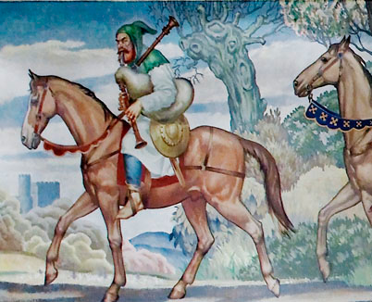 The MILLER was a stout churl, be it known,
Hardy and big of brawn and big of bone;
Which was well proved, for when he went on lam
At wrestling, never failed he of the ram.
He was a chunky fellow, broad of build; 5
He'd heave a door from hinges if he willed,
Or break it through, by running, with his head.
His beard, as any sow or fox, was red,
And broad it was as if it were a spade.
Upon the coping of his nose he had 10
A wart, and thereon stood a tuft of hairs,
Red as the bristles in an old sow's ears;
His nostrils they were black and very wide.
A sword and buckler bore he by his side.
His mouth was like a furnace door for size. 15
He was a jester and could poetize,
But mostly all of sin and ribaldries.
He could steal corn and full thrice charge his fees;
And yet he had a thumb of gold, begad.
A white coat and blue hood he wore, this lad. 20
A bagpipe he could blow well, be it known,
And with that same he brought us out of town.
- List everything you know about the Miller’s appearance. (Generally, the more Chaucer tells you about the physical appearance of a character, the less he likes them.)
Miller is a short and a stout man. He is chubby and has a broad torso. Also, he had a red beard and tuft air. He also had black and wide nostrils.
- For what purposes does the Miller use his great strength? Are these admirable actions?
Miller often heaved doors from their hinges and ran with his head. The actions are not admirable since they depict him as a show off.
- What can the Miller do well?
Miller can be a soilder and use his strengths to wield swords on the enemies to the community.
- How does the Miller take advantage of people? Is the Miller taking advantage of people as much as members of the clergy (church) taking advantage of people?
Miller used his strength to steal corn and full thrice charge his fees. Miller is not as hypocritic as the clergy members who hide behind religion to take advantage of the congregation.
- Chaucer states that the Miller was “a jester and could poetize.” However, in the next line he says that he talks mostly about “sin” and “ribaldries.” Look up ribaldries. What does this tell you about the Miller’s character?
The theme of Miller’s poems focus on the irrevant things of people instead of looking at their strengths and proficiencies. He is definitely a sdist since he derives pleasure from other people’s inadequacies.

